
AY2023/24 SEMESTER 2

BC2407 Analytics II
Title: ExxonMobil Maintenance Strategies
Tutor: Prof Hyeokkoo Eric Kwon
Tutorial Class: Seminar 5
Team: 1
Date of Submission: 31 March 2024
Group members | Matriculation Number
ALEX KHOO SHIEN HOW | U2220791B
LIM SWEE KEN | U2210378F
PHANG YONG CHENG | U2211500A
LIM SHI QI | U2210366D
POH YING EN JOY | U2210014H

Table of Contents
1. Executive Summary
2. Introduction
2.1 Significance of Power Outages
3. Methodology
3.1 Current Methodology
3.2 Limitations of Current Methodology
3.2.1 Limitation of Reactive Maintenance
3.2.2 Limitations of Preventive Maintenance
4. Opportunity Statement
4.1 Importance of Maintenance Solutions to ExxonMobil
4.1.1 Reduction in Maintenance Expenses
4.1.2 Reduction in Operational Downtime
4.1.3 Reduction in Safety Incidents
4.2 Importance of Maintenance Solutions to Government
4.2.1 Financial Considerations
4.2.2 Environmental Considerations
4.2.3 Geopolitical Consideration
5. Proposed Methodology
5.1 Overview
5.2 Model Evaluation Metrics
5.3 Gas Turbine Selected
5.4 Exploratory Data Analysis
6. Model Building
6.1 Baseline Model
6.2 Support Vector Machine (SVM)
6.3 Classification And Regression Trees (CART)
6.4 Random Forest
6.5 Lasso and Ridge Regression
6.6 Neural Networks
6.7 XG Boost
6.8 Model Results
7. Recommended Industrial Implementation
8. Limitations of Our Solution
8.1 Dynamic Operating Conditions and Other Environmental Factors
8.2 Spurious Relationships
9. Alternative Advanced Methods
9.1 Time Series Forecasting with Ensemble Techniques
9.2 Deep Reinforcement Learning
9.3 Challenges and Proposed Solution
10. Value of Proposed Methodology
10.1 Value for ExxonMobil
10.2 Value for Workers
10.3 Value for Engineers
10.4 Value for Government & Society
11. Conclusion
Appendix A: Optimal CART Model
Appendix B: Dashboard
Appendix C: References
Appendix D: Declaration of Academic Integrity

1. Executive Summary
Introduction. The integration of ExxonMobil’s chemical plants with its Singapore refinery has formed ExxonMobil’s largest integrated refining and petrochemical complex in the world.. Unplanned downtime due to power outages would adversely affect ExxonMobil production capacity, leading to diminishing revenue and affecting global petrochemical markets. Although ExxonMobil has implemented preventative and reactive maintenance strategies to maintain their gas turbines, the framework fails to pre-empt gas turbines and often results in over-maintenance and under-maintenance of gas turbines, leading to higher maintenance costs.

Proposed Solution. We’ll integrate the deployment of machine learning models with current maintenance solutions of ExxonMobil to leverage on predictive maintenance. Through predictive maintenance, we aim to minimise ExxonMobil downstream operations downtime due to gas turbine failure while minimising unnecessary maintenance.

Exploratory Data Analysis. We have collected data samples of GE H series power generation gas turbines from various companies, with 10,000 data records and 10 distinct features. The dataset includes the most significant features which we strongly believe will raffect machinery health of the gas turbine, such that a comprehensive machine learning model can be established.

Model Selection. We have trained and tested eight different models and we have chosen XGBoost as our final model as it has the highest accuracy, F1 score, F2 score and the model is known to be computationally efficient and flexible for large datasets.

Implementation of Our Solution. We plan to transmit gas turbine machinery data to a cloud-based data acquisition, storage and visualisation system, such as Microsoft Azure Cloud Computing Services. ExxonMobil engineers in the control centre of the ExxonMobil maintenance department can utilise our XGBoost model to predict gas turbine failure. Besides, engineers can utilise the cloud-based storage platform to devise condition-based maintenance management strategies by creating automatic-triggered alarms (e.g. Azure Monitor Alerts) that will alert technicians in the control centre when anomalous gas turbine behaviour is detected. We’ll introduce a human-in-the-loop approach to improve transparency in decision-making scenarios by incorporating human judgement in predicting gas turbine failure.

Limitations of Model. Our solution is limited by environmental factors and insufficient features to represent dynamic operation conditions of the gas turbine. We recommend ExxonMobil engineers to perform further data collection and retrain our XGBoost model if necessary. Our analysis on the variable importance result of XGBoost has highlighted that the model's results should not be taken as conclusive, as correlation does not imply causation.
We would like to assert that our findings in this paper may not apply to all scenarios, therefore we recommend ExxonMobil engineers consult relevant domain experts for further analysis of ExxonMobil gas turbines.

2. Introduction
Established in 1999, ExxonMobil Corporation is one of the world’s largest publicly traded American multinational oil and gas corporations. As a company that is vertically integrated across the entire petroleum and gas industry, ExxonMobil achieves an outstanding record of 3% world’s oil production and 2% of world’s energy production. (BSIC, 2023). Through the integration of ExxonMobil's chemical plants with its Singapore refinery, the company has established the world's largest integrated refining and petrochemical complex. Out of the total daily oil refining capacity of 1.5 million barrels, ExxonMobil has a production capacity of 592,000 barrels daily in Singapore, thereby contributing significantly to the fuels, oils and aromatics (Koons, 2023).

2.1 Significance of Power Outages
Considering the highly complex petrochemical and refining processes of ExxonMobil, it is essential to ensure safe and efficient production processes to avoid unplanned outages which will result in downstream profit reduction. The amplitude of poorly managed processes can be seen in outages at three refineries, including Exxon's Baytown, Texas’ plant where ExxonMobil downstream profit fell to $451 million in 2019 (Seba, E. 2019).

In Singapore’s ExxonMobil refinery that provides the largest contribution to the entity’s refining capabilities at 592,000 barrels a day (ExxonMobil, n.d.), gas turbines have become a crucial part of electricity generation to power up the operations of the entire facility since the full operationalisation of its cogeneration plant in the Jurong Island facility. The industry’s high dependence on electricity for its processes and operations can be seen in the power outages in US refinery HollyFrontier which sustained a loss of $98 million in just a quarter (Graf et al, 2013) - further stressing the importance of proper power generation system maintenance.

In the case of unforeseen failures in the cogeneration plant, alternative power sources are unavailable in power outage contingencies; the refinery facility electricity consumption upwards of 440MWh (ExxonMobil, n.d.) far surpasses mainland Singapore’s energy storage systems’ capacity of 200 Mwh (Begum, 2022). As unplanned downtime has severe financial ramifications, costing 35% more per minute than planned downtime (FORRESTER OPPORTUNITY SNAPSHOT: A CUSTOM STUDY COMMISSIONED BY IBM AUGUST 2019), it is of paramount importance to maintain high reliability of the power generation function to reduce unplanned downtime, such that ExxonMobil could optimise its business processes and expand its downstream operations efficiently.

3. Methodology

3.1 Current Methodology
As plant maintenance subject matter experts, maintenance engineers in ExxonMobil manage Standards of Environmental Care (SOEC), Global Pipeline Integrity (GPI), Hydrocarbon Controls Procedures (HCP), Safety Critical Equipment program in LOBP. These frameworks and standards allow ExxonMobil to make informed decisions in ensuring operational safety, environmental protection, and regulatory compliance of its facilities
Moreover, maintenance engineers of ExxonMobil are required to assist in plant maintenance activities by conducting regular timely inspection of Operations Integrity (OI) critical, High Consequence Process (HCP) systems and statutory equipment, especially for critical components such as. gears, bearings, lubricants and seals. The critical inspection of OI critical equipment and HCP systems are conducted to allow ExxonMobil achieve operational reliability and sustain a competitive advantage in asset utilisation (Field / Maintenance Engineer. n.d.).

Furthermore, ExxonMobil utilises advanced rotor-in major inspection (RIMI) techniques as part of its maintenance strategy for gas turbines, offering a safer, more efficient alternative to traditional rotor-out major inspections (FieldCore, 2019). Current Rotor-In Major Inspection (RIMI) techniques allow maintenance while the gas turbines in the cogeneration plant remain in service (Vernova, G. n.d.). While gas turbine operators still rely on rotor-out inspections, which involve the complex and risky process of lifting and removing of rotor, RIMI methods reduces environmental, health, and safety risks by lowering exposure from reduced work scope, streamlines logistics by requiring fewer interfaces with other contractors, and can save up to 30–40% of outage labour hours typically spent on component removal (Ge Vernova, 2024).

In 2019, ExxonMobil collaborated with Microsoft Azure in a computing agreement to utilise machine learning in collecting real-time data from oilfield assets, derive strategic drilling decisions by analysing drilling and completions data using Artificial Intelligence, detect immediate leaks, prioritise personnel deployment and monitor greenhouse gas emission (Reuters, 2019). However, the cloud technology is not deployed in downstream operations of ExxonMobil to minimise downtime in its operation due to power outages. Therefore, it is essential to acknowledge that current maintenance procedures in ExxonMobil still adopt planned and reactive maintenance modality as ExxonMobil is reliant on scheduled inspections and reactive repairs for gas turbine maintenance initiatives.

3.2 Limitations of Current Methodology
Maintenance strategies can be divided in three categories: reactive, preventive and predictive strategies. Scheduled or planned maintenance is a subset of preventive maintenance strategies.

3.2.1 Limitation of Reactive Maintenance
Reactive maintenance involves the maintenance of an asset only when the equipment breaks down and it is based on the assumption that downtime costs or necessary repair costs are insignificant. However, reactive maintenance strategies are only suitable for corporations with low-cost and non-critical assets that will not disrupt business operations due to equipment breakdown (What is reactive maintenance? | IBM. n.d.). ExxonMobil gas turbines are critical in ensuring continual downstream operations which are highly dependent on continual electricity supply.

While reactive maintenance strategies such as emergency maintenance, breakdown maintenance or run-to-failure maintenance seems to be cost-effective in the short term, long-term wear and tear on critical asset such as gas turbines may disproportionately inflate the total maintenance costs (Tyrrell, P. 2023) by leading to costly equipment repair and replacement, as well as increased downtime and energy consumption.

The need for turnarounds, which are scheduled maintenance, inspection and repair events at various refineries worldwide has indicated a need for further innovation and refinement in ExxonMobil's maintenance strategies to address these challenges and optimise asset performance and reliability.

3.2.2 Limitations of Preventive Maintenance
While RIMI procedures have scheduled maintenance benefits, it can only reduce operational downtime by up to 40%, suggesting that current solutions may not fully realise the potential for significant downtime reduction (Sontag, 2018). In fact, an increase in frequency of scheduled refinery maintenance, as reported by ExxonMobil (Magazine, B. 2020) has highlighted the ongoing challenges in maintaining operational efficiency within the downstream sector.

While preventive maintenance anticipates gas turbine failure through historical data analysis and schedule maintenance tasks at regular intervals in advance, most gas turbine failures are unexpected and thereby this may lead to over-maintenance or under-maintenance of machinery assets (Gulvin, 2023). Over-maintenance results in higher unnecessary maintenance resources and increases planned downtime whereas under-maintenance leads to frequent gas turbine failure due to increased wear-and-tear of components. This underscores the importance of transitioning towards more proactive maintenance approaches for long-term operational sustainability and cost-effectiveness (Schiff, T. 2016).

4. Opportunity Statement
Despite promising maintenance practices such as predictive maintenance programs being introduced in the industry, the reliance on reactive maintenance remains prevalent among industry operators. Therefore, our team has identified an opportunity to implement predictive asset maintenance for downstream machinery, particularly within the cogeneration plant in ExxonMobil operations to anticipate gas turbine failure such that downstream operations can be optimised.

Predictive Maintenance utilises data-based models and domain knowledge to anticipate future failures by analysing historical trends, behaviour patterns, and correlations such that maintenance decision-making process activity can be further improved (Zonta et al., 2020). This differs from preventive maintenance and reactive maintenance strategies which perform maintenance only after the asset has broken down or has been running to the point of failure respectively (Prometheus Group, 2022). Our team proposed to further integrate predictive solutions with existing maintenance strategies in ExxonMobil to leverage data
analytics in minimising chemical plant’s downtime due to power outages and enhancing petrochemical operations efficiency.

4.1 Importance of Maintenance Solutions to ExxonMobil
Gas turbine failures result in substantial financial implications due to operational disruptions, repair costs and potential hazards entailed. However, existing solutions such as planned maintenance may lead to costly over-maintenance due to unnecessary maintenance costs and increased planned downtime. Considering that energy is critical for ExxonMobil to power up downstream operations, maintenance solutions have to be optimised to balance between the two considerations.

4.1.1 Reduction in Maintenance Expenses
Predictive maintenance allows ExxonMobil maintenance engineers to emphasise on gas turbines that require maintenance, reducing the costs incurred from over maintenance. In fact, IoT-enabled predictive maintenance is associated with reduction of maintenance costs up to 30%, reduction of downtime up to 30% and extension of equipment lifespan up to 20% according to McKinsey & Company research.

4.1.2 Reduction in Operational Downtime
A single hour of downtime is estimated to cost over $100,000 according to 98% of organisations in a survey conducted by Information Technology Intelligence Consulting and this approximation may vary substantially according to the company size and the significance of its industrial operations. Predictive maintenance allows maintenance teams to foresee probable sources of failure ahead of time and this allows for adequate lead time for preparation, which minimises equipment downtime due to power turbine repairs. In fact, a report by Deloitte has suggested that predictive maintenance, which helps to reduce downtime, can lead to a 10-20% cost saving in maintenance alone, thereby indirectly boosting revenue (Deloitte, 2017).

ExxonMobil U.S. crude distillation unit (CDU) outages in the second quarter of 2019 has resulted in 16.4 million barrels of lost production, Moreover, a reduction in overall profits by $50 million due to outages at three ExxonMobil refineries in Baytown, Canada and Saudi Arabian plat has been recorded in 2019 June quarter. Through real-time monitoring of asset performance (Mehdi. 2023), predictive maintenance surpasses reactive maintenance and preventative maintenance strategies in reducing unplanned downtime and its associated detriments.

4.1.3 Reduction in Safety Incidents
The use of analytics in predictive maintenance will be invaluable in analysing historical accident data, equipment failure rates, and safety incidents to identify patterns and potential gas failure risks. Therefore, reduction in gas turbine failure due to predictive maintenance will lead to overall reduction in safety incidents.

A study has revealed that over 30% of major accidents experienced in the oil and gas industry were actually triggered by inadequate maintenance (Nwankwo et al., 2021). In fact, the ExxonMobil refinery explosion in Louisiana has indicated that most equipment in ExxonMobil refineries were not properly maintained and inspections were not carried out within required periods. ExxonMobil plants have received U.S. Occupational Safety and Health Administration (OSHA) citations and legal penalties due to incompetent emergency preparedness systems and monitoring of potential risks on the alkylation unit (Seba, E. 2017, July 14). Therefore, financial losses due to transgression of national laws and regulations can be avoided in ExxonMobil power plants if gas turbines were maintained properly.

4.2 Importance of Maintenance Solutions to Government
Considering the considerable stakes of ExxonMobil corporation in Singapore, maintenance strategies employed by ExxonMobil are significant in advancing the interest of the Singapore Government.

4.2.1 Financial Considerations
Supporting the creation of a predictive maintenance model to mitigate engine failure aligns with Singapore's interests due to its significant reliance on the oil and gas industry for economic stability and growth. ExxonMobil alone accounts for one third of Singapore’s total refinery capacity, highlighting the industry's pivotal role in advancing the nation's economy. The energy and chemicals sector, including oil and gas, contributed a substantial S$113.1 billion to Singapore’s Total Manufacturing Output in 2022, accounting for 25% of the total output (Edb.gov.sg. n.d.). Moreover, this sector contributes up to 2.3% to the nation's GDP (Koons, E., 2022). Given the substantial economic impact of ExxonMobil operations, ensuring the reliability and efficiency of operations within this industry through predictive maintenance strategies is imperative to sustain Singapore's economic growth trajectory and maintain its attractiveness to foreign investments.

4.2.2 Environmental Considerations
Advocating for the implementation of predictive maintenance models in Singapore's oil and gas sector carries significant environmental implications.

Machineries failures within this industry pose a substantial hazardous risk, as evidenced by past incidents such as the Exxon Baytown incident which affected approximately 5,000 individuals in the vicinity due to the release of toxic pollutants, leading to over 60 people requiring medical evaluation (Chantal Da Silva, 2021). These events not only result in severe air pollution but also have long-lasting environmental consequences, including harm to ecosystems and public health (Associated Press & Doha Madani, 2019). By leveraging predictive maintenance technologies to prevent such failures, Singapore can mitigate the environmental impact of downstream petrochemical operations, promoting sustainability and safeguarding the well-being of its citizens and local ecosystems.

4.2.3 Geopolitical Consideration
Trading is a crucial aspect of Singapore’s economy, with external demand contributing to around 62% to 72% of the country’s GDP (Liu et al., 2023). The emphasis and constant effort Singapore has placed on the trading sector have enabled Singapore to emerge as a pivotal shipping hub in Asia and one of the world's premier oil trading and refining centres, underscoring its strategic importance in global trade and energy dynamics (export.govt, 2019). Out of the total oil refining capacity of 1.5 million barrels a day, only a fraction is allocated for Singapore’s own energy needs, while the remainder serves as a crucial energy export product for Asia and beyond (Koons, 2022). This aspect is particularly relevant to ExxonMobil, a significant player in Singapore's oil and gas industry, as its operations contribute substantially to this refining capacity, thereby reinforcing its integral role in supplying energy products to regional and global markets. Given its crucial role in facilitating international maritime transportation and energy logistics, ensuring the reliability and security of oil and gas operations through predictive maintenance is paramount. By safeguarding the uninterrupted flow of energy resources through its territory, Singapore can bolster its geopolitical influence and maintain stability in regional and global energy markets.

5. Proposed Methodology

5.1 Overview
The purpose of this section is to establish a robust and comprehensive machine learning model to effectively identify the root causes of gas turbine failures using variable importance analysis and to accurately predict gas turbine failure using available historical and real-time gas turbine data.

We have retrieved average machinery metrics collected for different gas turbine models and the subsequent occurrence of failure in the next period. The historical data will enable the discovery of intricate relationships between average machinery metrics and its occurrence of failure for the next period, thereby allowing the effective prediction of gas turbine failure in the next period such that ExxonMobil engineers can intervene before the turbine fails.

Furthermore, we will establish a baseline model of simple linear logistic regression to be used as a benchmark comparison with more complex models. We will select the optimal model that outclassed other models based on model performance of four metrics: F1 Score, F2-Score, Log Loss and Accuracy, with F1-score being the primary evaluation metric.

5.2 Model Evaluation Metrics
- F1 Score
The F1-score performance of ML models will be prioritised considering that it provides a harmonic mean between precision and recall. Precision emphasises on the necessity to minimise false positive errors whereas recall measures the model performance on reducing false negatives. Considering that false positives lead to unnecessary maintenance and false negatives result in neglected maintenance and both of which incur expenses for Exxonmobil, this performance measure is essential in balancing between false alarms and missed detections. Moreover, F1-score can effectively handle imbalanced datasets, thereby reducing the model bias.

$F_{1} = \frac{2 * Precision * Recall}{Precision + Recall}$
$F_{1} = \frac{True Positives}{True Positives + 0.5 (False Positives + False Negatives) }$

- F2 Score
F2-Score emphasises on reducing false negatives more over false positives by providing recall a larger weight than precision. This valuation metric may be significant considering that false negatives (gas turbine failure) may incur higher costs than false positives (higher maintenance expenses). However, it is significant for ExxonMobil engineers to validate this assumption by conducting pilot studies before utilising this metric as general assumptions may not apply in ExxonMobil operations.
$F_{2} = \frac{5}{\frac{4}{Precision} + \frac{1}{Recall} }$
$F_{2} = \frac{5}{\frac{4TP + 4FN}{TP} + \frac{TP + FP}{TP} }$
- Accuracy
Accuracy is essential to reflect all true predictions made by the model and it is pivotal in assessing the significance of gas turbine maintenance. Through accurate predictions, gas turbine maintenance is performed only when it is necessary, thereby allowing ExxonMobil to optimise resource allocation, including labour, parts, and equipment. However, accuracy metric may not reflect model’s performance on minority class when the dataset is imbalanced.

$Accuracy = \frac{True Positives + True Negatives}{True Positives + False Negatives + False Positives + False Negatives }$

- Logarithmic Loss
Log loss is applied to account for the model's prediction uncertainty, where false classifications are penalised based on probability estimates / confidence of predictions. Therefore, the metric allows model comparison based on degree of confidence in their predictions and this enables the selection of the most reliable model. The probability of prediction represents the expected probability of

5.3 Gas Turbine Selected
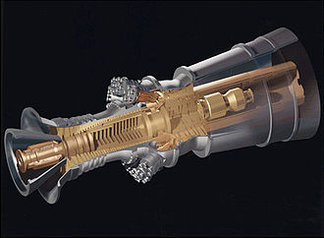
Figure 1: GE H series power generation gas turbine

We have chosen the GE H series power generation gas turbine as our power generation gas turbine based on two reasons: first, the 605 MW General Electric 9HA which achieved a high thermodynamic efficiency rate of 62.22% is used frequently deployed at efficient combined-cycle power plant, and second the series can effectively complement intermittent power generation from renewable sources, which will enable ExxonMobil to venture into the renewable energy generation sector in the future. We strongly believe that our analysis on this gas turbine will provide substantial insights on ExxonMobil maintenance operations. (Vernova, G. n.d.).

5.4 Exploratory Data Analysis
Our dataset contains 10,000 data points and 10 unique features, including features such as Air Temperature, Process Temperature, Rotational Speed, Torque, Tool Wear and Target (‘0’ = non-failure, ‘1’ = failure) as we aim to establish a model that predicts the gas turbines failures in ExxonMobil's cogeneration plants based on operational and environmental factors such as turbine performance, environmental conditions and historical failure events. The large amount of machinery data will facilitate diverse angles of data analysis and machine learning model development.

Missing Values. We have identified that there are no missing variables in our data set.

Skewness of Variables. We found that the Rotational Speed variable has high positive skewness at 2.73 (2.d.p) and we thus applied the logarithmic function to reduce the skewness to 2.11 (2.d.p). Acknowledging that the skewness score still remains relatively high, we’ll select models without “no skewness” assumption .

Relationship between Torque and Rotational Speed: We found out that torque and rotational speed have an inverse relationship. As rotational speed increases, torque decreases.
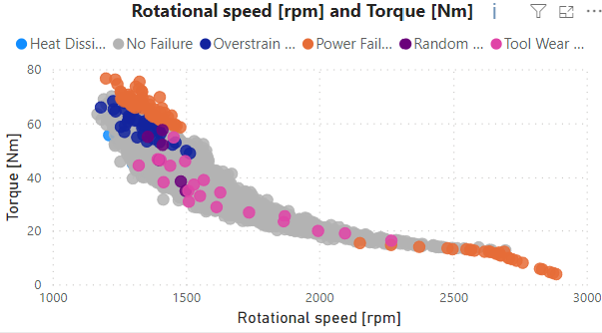
Figure 2: Relationship of Torque and Rotational Speed of Gas Turbine

Undersampling
We noticed a class imbalance in our Y variable (Target) which consisted of 9661 and 331 instances of non-failure and failure respectively. Therefore, we undersampled the 9661 non-failure occurrences to 331, matching that of the failures to retain the data in the original dataset and reduce model bias.

Min-Max Scaling
Re-scaling (min-max normalisation) of the independent, continuous variables to a range of [0,1] is performed to ensure that each independent, continuous variables’ contributions to the classification model are scaled to the same magnitude, using the formula:
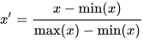

Encoding of Categorical Variables
Through our data exploration, we identified that the variables Type and Failure Type were categorical variables. The categorical dependent variable (Target) is also encoded such that 0 represents absence of failure, and 1 represents presence of failure. Considering that there are 3 categories (L, M, H) in the independent variable (Type), one-hot encoding is performed.

6. Model Building

6.1 Baseline Model
We have decided to use a logistic regression model as a baseline model due to the higher model interpretability and the dependent variable being a binary variable.

For the test set, our logistic regression model has achieved an accuracy score of 0.804, F1-score of 0.810, F2-score of 0.824 and Log Loss of 16.955. The lower performance of these metrics may be due to the assumption of linearity where linear relationships between input features and the log-odds of the dependent variable are assumed.

6.2 Support Vector Machine (SVM)
A linear kernel SVM model is used to find the optimal multidimensional hyperplane that maximises the margin size between support vectors (observations with the closest proximity to the hyperplane) with absence of failure (Target == 0) and presence of failure (Target == 1), using the default C-Classification method with linear kernel, allowing the model to be less influenced by outliers. The optimal hyperplane will separate the data points into two separate clusters.

For the test set, our logistic regression model has achieved an accuracy score of 0.799, F1-score of 0.800, F2-score of 0.802 and Log Loss of -34.540. Our SVM model has performed poorer as compared to our baseline model, and this may indicate that non-linear kernels or other machine learning models may perform better.

6.3 Classification And Regression Trees (CART)
Further exploration has been conducted on non-linear classifiers due to the assumption of linearity for our baseline model and that outliers values will have minimal effect on tree models. Non-linear classifiers such as CART model can capture complex non-linear relationships between independent features and categorical target variables by recursively splitting the input features to maximise information gained.

Each binary split of our CART model is calculated based on the splitting criteria of Gini Impurity. The model was grown to its maximum and was pruned afterwards using the minimum to prevent overfitting. According to our variable importance plot, we found that operational factors such as torque and rotational speed were more significant in determining gas turbine failure as compared to environmental factors.
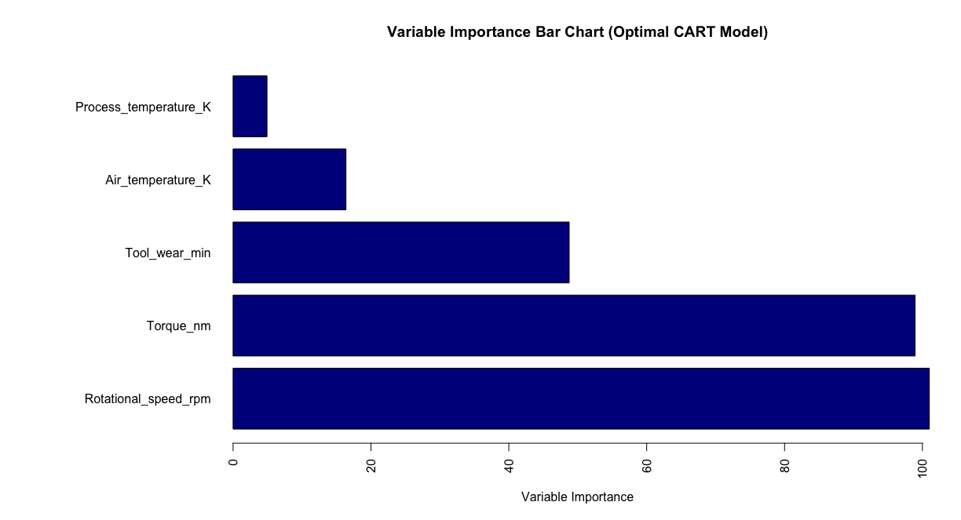
Figure 4: Variable Importance Barplot of CART Model

For the test set, our CART model has achieved an accuracy score of 0.931, F1-score of 0.933, F2-score of 0.950 and Log Loss of 17.025. Our CART model has substantially outperformed the previous models and this indicates that the independent variables and target outputs may have non-linear relationships.

6.4 Random Forest
To increase the stability of the CART model, we have modelled a Random Forest Model to capitalise on methodologies such as Bagging (Bootstrap Aggregating) and Random Subset Feature (RSF) Selection.

Bootstrap Aggregate involves the generation of multiple subsets of the original dataset through bootstrap sampling, where samples are drawn from the original dataset with replacement. Each subset of the original dataset will be utilised to train a separate decision tree. RSF Selection enhances the capturing of complex relationships between variables and ascertain variable importance by providing different combinations of observations at each split in the growth of a CART decision tree. As each split is made by maximising the node purity of child nodes, RSF Selection is used to induce controlled instability to the model The model then predicts the possibility of gas turbine failure by aggregating all the predicted values from individual decision trees.

Our model’s performance has a 9.49% Out Of Bag Misclassification Error Rate and this result was obtained by testing with the observations not selected during the RSF Selection for the growth of each tree. The presence of dominant variables such as Rotational_speed_rpm and Torque_nm which has Mean Decrease in Gini at 67.008005 and 65.120127 respectively (while mean of Mean Decrease in Gini for all variables remain at 27.39627) may lead to diminish the effect of bagging on model stability.

For the test set, our Random Forest model has achieved an accuracy score of 0.931, F1-score of 0.934, F2-score of 0.956 and Log Loss of 17.016. Our Random Forest has outperformed the CART model on all valuation metrics by a slight margin. According to the variable importance plot of Random Forest, torque_nm and rotational_speed_rpm seems to be the most significant variable in determining the best binary split.
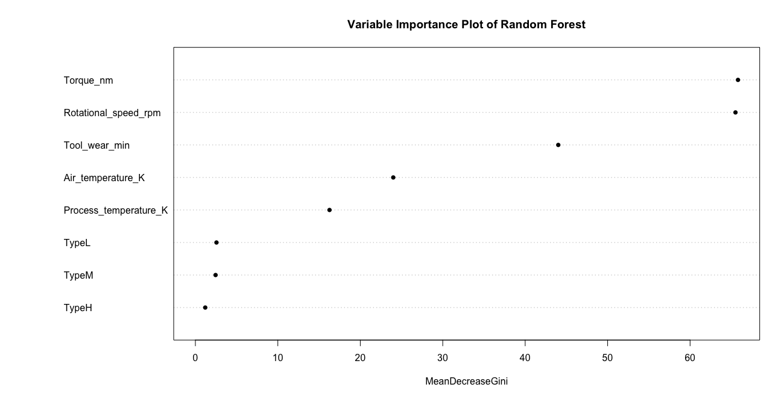
Figure 5: Variable Importance Chart of Random Forest

6.5 Lasso and Ridge Regression
We further explore lasso and ridge regression techniques to introduce penalty terms in our model such that overfitting of machine learning models can be reduced. The key difference between the two models is the type of penalty terms imposed on the cost function.

Ridge Regression
Ridge regression implements a “squared magnitude” of coefficients as a penalty term to the loss function also known as the L2 regularisation term, affecting the overall test Mean Squared Error. The formula is as shown below:
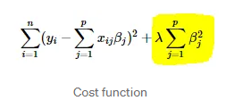
Lasso Regression
Similar to Ridge Regression, Lasso Regression instead adds an “absolute value of magnitude” of coefficient as a penalty term to the loss function also known as the L1 regularisation term. The formula is as shown below:
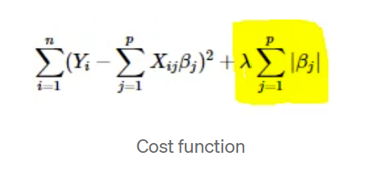
The regularisation terms imposes a penalty term on the size of coefficients, thereby promoting the formulation of models with smaller coefficients and improves generalisation performance.

We have modelled both models using the lambda value that produces the lowest test mean squared error found through 10-fold cross-validation. As our dependent variable is discrete, we set the threshold at 0.5 to predict gas turbine failure.

For the test set, our lasso regression model has achieved an accuracy score of 0.804, F1-score of 0.810, F2-score of 0.824 and Log Loss of 17.320 whereas our ridge regression model has achieved an accuracy score of 0.804, F1-score of 0.802, F2-score of 0.797 and Log Loss of 17.320. The lower predictive performance for both models may suggest that both models are not ideal in predicting gas turbine failure.

6.6 Neural Networks
Considering that neural networks are able to comprehend more complex non-linear trends between the variables that may not be captured by other models, we have modelled a neural network model with 4 hidden layers having 6,6,4 and 2 neurons in each layer respectively. As our objective is to predict gas turbine failure and the output variable is a categorical variable, we have chosen the cross-entropy error function to guide the training process of the neural network.

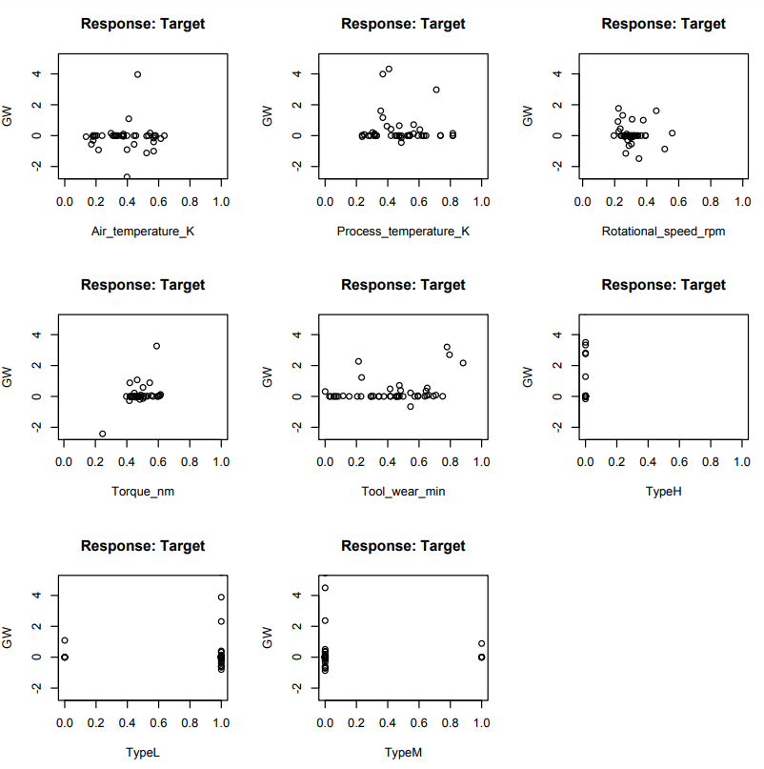
Figure 6: GWplot of neural network model

The GWplot of neural network models indicates that process temperature, torque and tool_wear might have a positive relationship with the Target Variable.
For the test set, our neural network model has achieved an accuracy score of 0.858, F1-score of 0.863, F2-score of 0.880 and Log Loss of 5.086. While the neural network models has achieved better performance in log loss compared to previous models, the performance of the model in accuracy score, F1-score and F2-score is poorer than Random Forest, albeit the model performed better in all aspects as compared to the baseline model. It is essential to note that neural networks perform better in larger datasets. However, given that neural networks have higher complexity which results in higher computational costs, ExxonMobil maintenance teams may prefer other models for downstream operations.

6.7 XG Boost
XG boost is a machine learning algorithm that implements gradient boosting framework by
training an ensemble of shallow trees and using the error residuals of the previous model to fit the next model. This process will eventually build up the optimal classification / regression model.
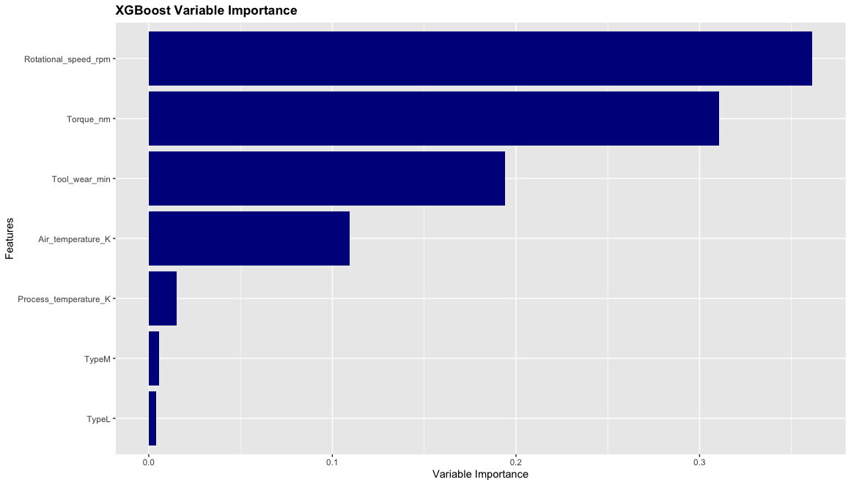
Figure 7: Variable Importance Bar Chart of XGBoost

According to the variable importance analysis on our XGBoost model, rotational_speed_rpm and torque_nm seem to be the two most significant variables in predicting gas turbine failure. For the test set, our XGBoost model has achieved an accuracy score of 0.972, F1-score of 0.938, F2-score of 0.957 and Log Loss of 16.609. It is evidence that out XGBoost model performed the best in terms of Accuracy, F1 score and F2 score.

Considering that both Random Forest model and XGBoost model have the two highest F1-score performance across all models, we have performed 10-fold cross validation to obtain a more stable Random Forest model and XGBoost model. Since XGBoost has the highest overall accuracy rate, F1-score and F2-score, we have chosen XGBoost as our final predictive model despite its relatively higher log-loss score as compared to neural networks. This is because the maintenance costs of a gas turbine more often far exceeds the cost of a less confident prediction.

6.8 Model Results
Method | Model | Accuracy | F2 Score | Log Loss | F1 Score
Linear | Logistic Regression | 0.804 | 0.824 | 16.955 | 0.810
Non-Linear | Lasso Regression | 0.804 | 0.824 | 17.320 | 0.810
 | Ridge Regression | 0.804 | 0.797 | 17.320 | 0.802
Cluster Based | Support Vector Machine | 0.799 | 0.802 | -34.540 | 0.800
Tree | CART | 0.931 | 0.950 | 17.025 | 0.933
 | Random Forest | 0.931 | 0.956 | 17.016 | 0.934
 | 10-Fold Random Forest | 0.930 | 0.956 | 17.016 | 0.934
Neural Network | Neural Net | 0.858 | 0.880 | 5.086 | 0.863
Gradient Boosting | XG Boost | 0.936 | 0.957 | 16.609 | 0.938
 | 10-Fold XG Boost | 0.971 | 0.957 | 16.609 | 0.938
Table 1: Metric Scores Reflecting Model Performance

7. Recommended Industrial Implementation
Since the Exxon Valdez oil spill incident of 1989, ExxonMobil employs Operational Integrity Management Systems - a comprehensive disciplined management framework which comprises different practices, such as Standards of Environmental Care (SOEC), Global Pipeline Integrity (GPI), Hydrocarbon Controls Procedures (HCP), Safety Critical Equipment program for risk analysis, performance monitoring and asset maintenance such that preventative maintenance can be completed with minimum downtime. Adopting this framework, ExxonMobil maintains documentation records to maintain the mechanical integrity However, despite the regular inspection of machinery health and significant reduction in Lost Time Incident Rates (Operations Integrity Management System: Chairman’s message. n.d.) under this framework, the frequency of asset degradation that leads to unexpected gas turbine failure remains high for the asset intensive refining and petrochemical complex, as mentioned earlier. Therefore, our proposal aims to incorporate a combination of condition-based maintenance (reactive maintenance) and prognostic and health management (predictive maintenance strategies) strategies to effectively provide a comprehensive technical framework in asset maintenance (Achouch, M. et al. 2022).

We’ll then integrate the deployment of machine learning models with current maintenance solutions adopted by the maintenance department of ExxonMobil. Our solution will include a real-time cloud monitoring system/dashboard where maintenance personnel in the department can observe the status of the gas turbine based on real-time machinery data.

The technical implementation of our proposal will begin with the installation of sensors and relevant instruments that are able to accurately record machinery features, such as torque, rotational speed, process temperature etc. The sensors will transmit data to a cloud-based data acquisition, storage and visualisation system, such as Microsoft Azure Cloud Computing Services (e.g. Azure IoT Hub & Azure Data Explorer) which enables real-time monitoring and historical trend analysis of machinery data (Gremban, K., et al. n.d.). The system will be accessed and managed by the data scientists in the control centre of ExxonMobil maintenance department, who will utilise our XG Boost model to effectively predict the class probability of gas turbine failure in ExxonMobil operations. The predicted probabilities of failures can be appended to the documentation maintained by ExxonMobil maintenance department for continuous evaluation and assessment to determine whether scheduling maintenance for a specific gas turbine is required.

Aside from predictive maintenance strategies under prognostic and health management, relevant engineers can utilise the cloud-based storage platform to devise condition-based maintenance management strategies by collecting and analysing critical sequential data that represent the machinery health of operating gas turbines. Data Engineers in ExxonMobil maintenance department can analyse the historical trends of machinery data using Microsoft Azure dashboards and create automatic-triggered alarms (e.g. Azure Monitor Alerts) that will alert technicians in the control centre when anomalous gas turbine behaviour is detected, that is when the collected gas turbine metrics exceed certain thresholds, indicating significant probability of machine degradation (Lavi Mendes, N. n.d.). However, condition-based maintenance strategies are effective only when there is direct evidence of machine degradation and this might not assist in reducing unplanned outages (Achouch, M., et al. 2022) . Therefore, the approach should be integrated with predictive maintenance strategies to effectively address unplanned outages of critical equipment and.ensure accurate asset inspection (ExxonMobil, 2022)

However, it is essential to note that despite the higher F1 score achieved by our XG Boost model in predicting gas turbine failure, ExxonMobil engineers may be hesitant to adopt the predictive results of XGBoost due to concerns on the black box nature of the machine learning model. While XGBoost provides parallel tree boosting which improves the efficiency of the algorithm, the model has higher complexity and lower interpretability, and thus it might be strenuous for ExxonMobil engineers to comprehend how the model arrives at the class probability and boolean conclusion based on raw machinery data (Vikas Hassija et al., 2023). In fact, this concern is validated by a study where 42% of SAS data managers and scientists claimed that their analytical results were not utilised by business-decision makers while potential data and algorithmic bias has resulted in increased resistance by the business management team to adopt data-driven practices (McKendrick, J. 2022) . Hence, the lack of accountability for machine learning errors (Vikas Hassija et al2023) and the probabilistic nature of prediction results may result in engineers relying solely on their own human judgement without regard to the model’s predictions, thereby rendering our proposal ineffective in tackling unplanned downtime due to gas turbine failure.

Therefore, our approach in addressing this concern is to introduce a human-in-the-loop approach to improve transparency in decision-making scenarios, e.g. scheduling maintenance for gas turbines, thereby enhancing the trust and adoption of XGBoost model by incorporating human judgement in predicting gas turbine failure (Masaya Mori. 2020). A two-factor authentication process can be adopted where the first factor being the model prediction results such as the predicted boolean results and probability score of potential gas turbine failures, and the second factor as the engineer’s technical expertise in determining machine failure according to specific important features such as torque and rotational speed.

This would establish a collaborative partnership between expert evaluation and the XGBoost model where engineers can better exercise their judgement with the XGBoost model complementing the engineer’s decision through knowledge augmentation by providing underlying insights on model deductions. On the other hand, the engineer could analyse and validate the model’s predictions by incorporating domain knowledge in decision-making, thereby reducing unforeseen errors and biases of our XG Boost model through feature engineering and hyperparameter optimisation. By establishing oversight and quality control of XGBoost model outputs, the technicians’ feedback will further contribute to trust and acceptance of the model’s outputs and further improve the model’s adaptability in handling more complex scenarios (Emre Sezgin. 2023).

When the probabilistic output of XGBoost model suggests a high likelihood of gas turbine failure, ExxonMobil engineers will be alerted to update maintenance records and schedule maintenance / inspection for the particular gas turbine, while activating other backup power generators in the meantime or seeking alternative sources of power outputs to ensure that downstream petrochemical and refinery operations remain undisrupted.

If the XGBoost model predicts gas turbine malfunction with a confidence level slightly exceeding a marginal probability of 50%, ExxonMobil technicians may dispatch technicians to observe the present and historical metrics of the specific gas turbine while corroborating with the model’s insights and other records before deciding that the anomaly is a valid cause of concern. Therefore, the XGBoost model will no longer be a sole decision maker, but an added complementary tool in predicting gas turbine failure (Emre Sezgin. 2023) and this feedback loop will effectively reduce inaccurate gas turbine failure predictions such as false positives which will lead to unnecessary additional maintenance cost.

Aside from the technical framework, we plan to introduce an agile management approach integrated with lean methodologies such as total productive maintenance framework to ensure sustainable operational management and asset maintenance. Total productive maintenance framework ensures cross-collaboration with the management and workers in asset maintenance, thereby significantly enhancing predictive maintenance procedures (Pharaon, Jean W 2022).

8. Limitations of Our Solution

8.1 Dynamic Operating Conditions and Other Environmental Factors
The current dataset does not fully capture the entire dynamic operating condition of a gas turbine, as with any dataset. At a closer inspection, our dataset does not include variables such as age which indicates the expected remaining lifespan of a gas turbine, operational hours nor frequency and quality of maintenance practices. It is essential to acknowledge that these variables are most likely to have a significant influence on gas turbine breakdown as longer operational hours and lower frequency and quality of maintenance practices would lead to significant wear and tear of overstrained components, especially in old gas turbines. Considering that our models were not trained based on these variables, we do expect a significant variation in expected model performance of our XG Boost model.

While our XG Boost model has achieved a significantly high F1 score 0.938, the model may be trained by data affected by seasonal variations. For instance, higher demand for ExxonMobil downstream products during a particular season may increase the operational hours or required power output of a gas turbine. Besides, higher temperatures during summer may lead to increased average temperature of gas turbines and coating degradation while lower temperature during winter periods may lead to higher frequency of wear and tear of gas turbine components due to increased viscosity lubricant (Chowdhury et al., 2023). Our XG model may be predominantly trained on a dataset from a specific season and thereby the model may not be robust to seasonal variations.

Proposed Solution: ExxonMobil can perform additional data collection on seasonal features such as humidity or operational hours per season and machinery features such as age and frequency of maintenance, such that the model can recognise more factors that influence gas turbine health. This will provide a more appropriate description of the environment each gas turbine resides in, thereby improving the predictive accuracy of our XG Boost model. Besides, ExxonMobil engineers may regularly retrain the machine learning models deployed to avoid model drifting which might lead to degradation of model performance over time.

8.2 Spurious Relationships
While most feature importance results of our predictive models indicate that torque and rotational speed are significant in predicting machine failure, it is essential to acknowledge the potential presence of a confounding (“hidden”) factor / feature that may directly contribute to this finding. Therefore, ExxonMobil should be aware that the variable importance results merely indicate correlation between independent variables and gas turbine failure, and thus does not imply causation.

Proposed Solution: To avoid “tunnel-vision” where ExxonMobil engineers placing excessive emphasis on “important features” found in this report, we recommend ExxonMobil engineers conduct a pilot study and engage with gas turbine domain experts to further validate our findings.

9. Alternative Advanced Methods
Although our analysis has indicated that the XGBoost and Random Forest model has outperformed other models substantially using our synthetic dataset, these models might not perform well in certain edge cases. Therefore, we do believe that further research and analysis should be conducted by ExxonMobil researchers to evaluate the performance of other advanced models such as time series forecasting models and deep learning models. However, we firmly believe that there is no “best model” in predictive maintenance and thus ExxonMobil engineers may leverage on the different capabilities of machine learning models and deep learning models to significantly enhance the efficacy and effectiveness of our predictive maintenance solutions.

9.1 Time Series Forecasting with Ensemble Techniques
Time Series Forecasting models such as Long Short-Term Memory (LSTM) neural networks are effective in capturing the underlying seasonality and trends of machinery failure. As mentioned before, seasonal variations may lead to significant deviations in predictive performance of our models. In the context of predictive maintenance, we propose to establish a hybrid CNN-LSTM deep learning framework to leverage on ensemble machine learning techniques for multivariate time series classification (Wahid, A. et al. 2022) as LSTM model which could effectively handle the exploding/diminishing gradient issue present in traditional RNNs and ensemble models has been proven to outperform single models in various domains (Mohammed, A., & Kora, R. 2023). According to Wahid, A. et al.2022, the hybrid CNN-LSTM model may utilise convolutional features of Convolutional Neural Networks (CNN) to extract short-term dependencies and a Long Short-Term Memory neural network for prediction. The architecture has been proven to outperform single deep learning models such as CNN or LSTM.

9.2 Deep Reinforcement Learning
Aside from predictive maintenance strategies, ExxonMobil engineers can optimise the efficacy of planned maintenance schedules and its planning through the modelling of deep reinforcement learning AI agents (Ogunfowora, O., & Najjaran, H. 2023). Reinforcement techniques such as Deep Q-Learning can be used to identify the most optimal dynamic maintenance actions that minimise penalties (e.g. monetary loss due to unplanned outages) by leveraging the idea of Markov Decision Process.

9.3 Challenges and Proposed Solution
However, while the higher dimensionality of hybrid deep learning models can uncover intricate underlying patterns of the dataset and deep reinforcement learning agents can minimise monetary due to unplanned downtime effectively, ExxonMobil engineers should not discount the risk of overfitting. Besides, these models typically result in higher computational costs and lower interpretability of results. Therefore, these methods may be applied when the ExxonMobil management is relatively receptive to data-driven solutions even considering the black-box nature of deep learning models.

10. Value of Proposed Methodology

10.1 Value for ExxonMobil
Through predictive failure classification, our predictive model can augment ExxonMobil’s current maintenance initiatives by evaluating gas turbines operational factors and environmental factors in cogeneration plants. Considering that the cogeneration plant is essential for ExxonMobil to supply energy for downstream operations, our predictive model will improve the productivity and efficiency of Exxonmobil's downstream operations by significantly reducing unplanned operational disruptions. This is because ExxonMobil engineers can perform maintenance precisely and proactively only when it is required.

Additionally, the model reduces unforeseen financial costs by safeguarding against expensive unplanned emergency repairs. This results in a more efficient and strategic resource allocation of manpower and financial resources to improve operational effectiveness, thereby increasing ExxonMobils’ revenue and downstream operations output.

10.2 Value for Workers
Lowering the likelihood of turbine malfunction also lowers the exposure to the potential risk of workplace accidents brought on by malfunctioning gas turbines. This will result in higher employee safety of ExxonMobil workers in the energy plant, given the high-risk nature of working in cogeneration facilities due to higher energy output.

10.3 Value for Engineers
Our model enables us to identify intricate hidden patterns and novel relationships in data with our approach by discovering hidden relationships between independent and dependent variables. Through variable importance analysis, ExxonMobil engineers can emphasise on certain sensor data to better maintain the gas turbines in cogeneration, thereby improving maintenance quality and maximising Exxonmobil's maintenance resources. Relevant insights on the magnitude of importance of certain variables may also effectively address human biases in judging whether maintenance is required for a particular gas turbine.

10.4 Value for Government & Society
As a major oil and gas industry company operating in Singapore, Exxonmobil downstream operations are pivotal in developing Singapore’s economy. By reducing unplanned downtime of their cogeneration plants due to gas turbine failure, the efficiency of ExxonMobil operations can be enhanced and thus this will benefit Singapore’s economy. Additionally, as cogeneration plants offer lower carbon emissions as compared to gas-fired, oil-fired and coal-fired plants, predictive maintenance ensures that engines have a lower chance of failure, allowing the plant to have longer uptime. This would help Singapore maintain lower carbon emissions in terms of power generation, aligning with its goal of attaining net-zero emission by 2050.

11. Conclusion
Our findings in this paper has led to us proposing the XGBoost model as the optimal model in predictive maintenance. We proposed a comprehensive technical solution revolving around predictive maintenance and reactive maintenance to further optimise current maintenance solutions adopted by ExxonMobil such that downtime on downstream operations can be reduced effectively. Despite potential limitations of our model, our proposal would deliver substantial value to ExxonMobil management through optimisation of asset utilisation.

Appendix A: Optimal CART Model

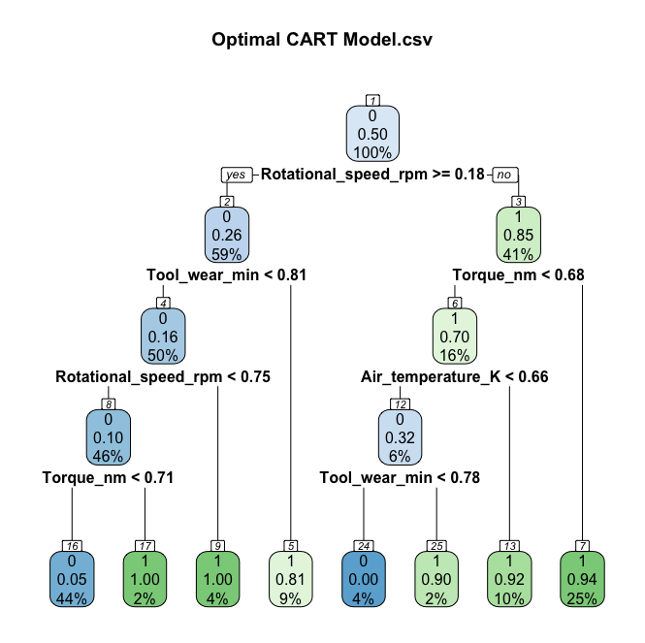

We have generated the simplest optimal CART model using the most optimal prune trigger value. The Classification and Regression Tree model will be utilised to predict gas turbine failure.

Appendix B: Dashboard
Home page:
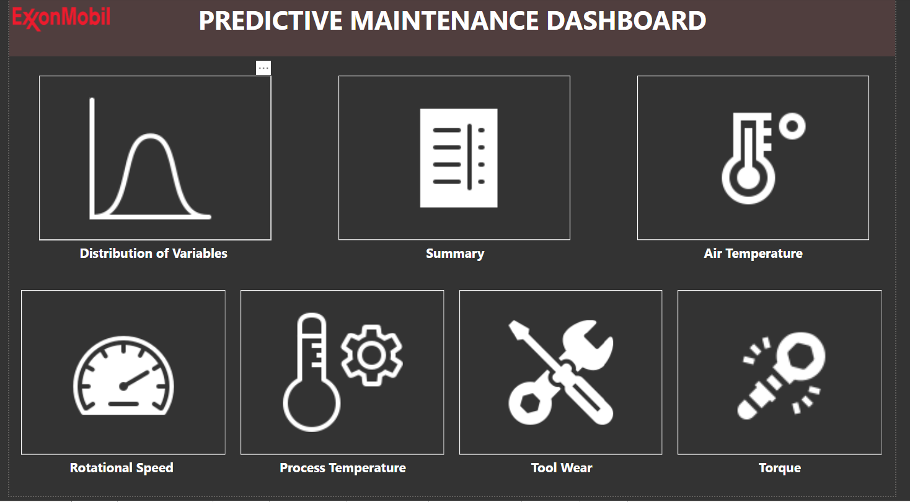

Distribution of Variables:
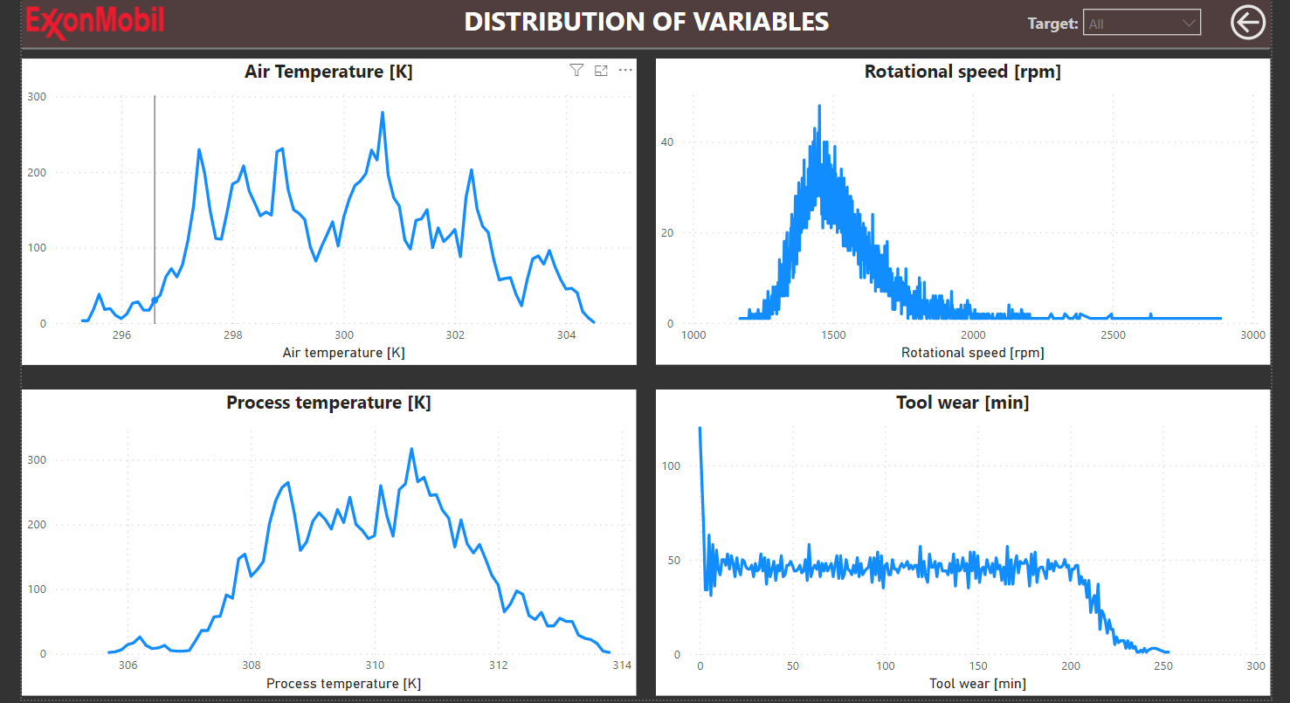

Summary:
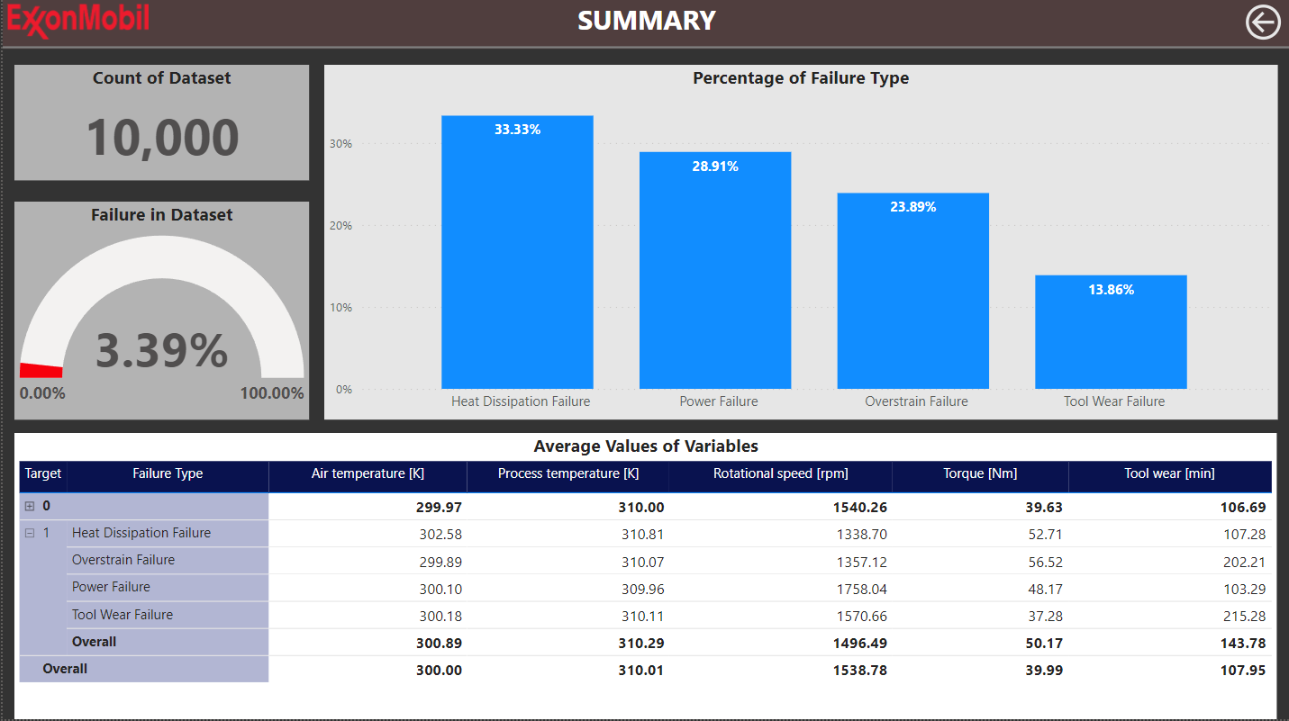
Air Temperature Variable:
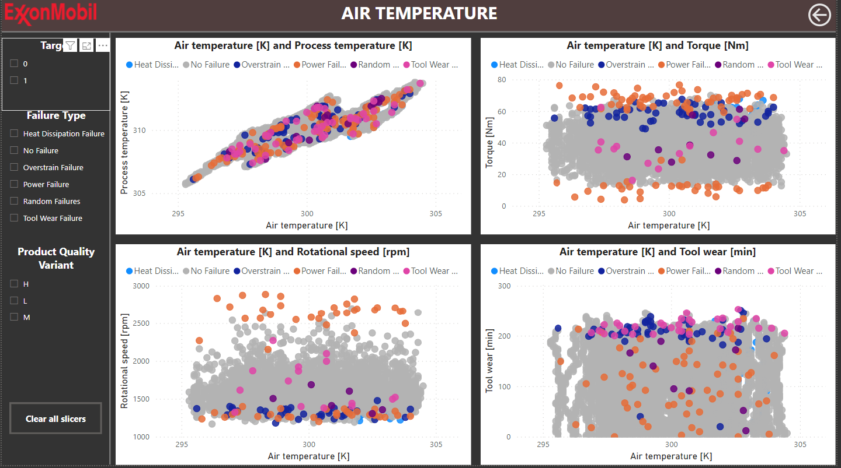

Rotational Speed Variable:
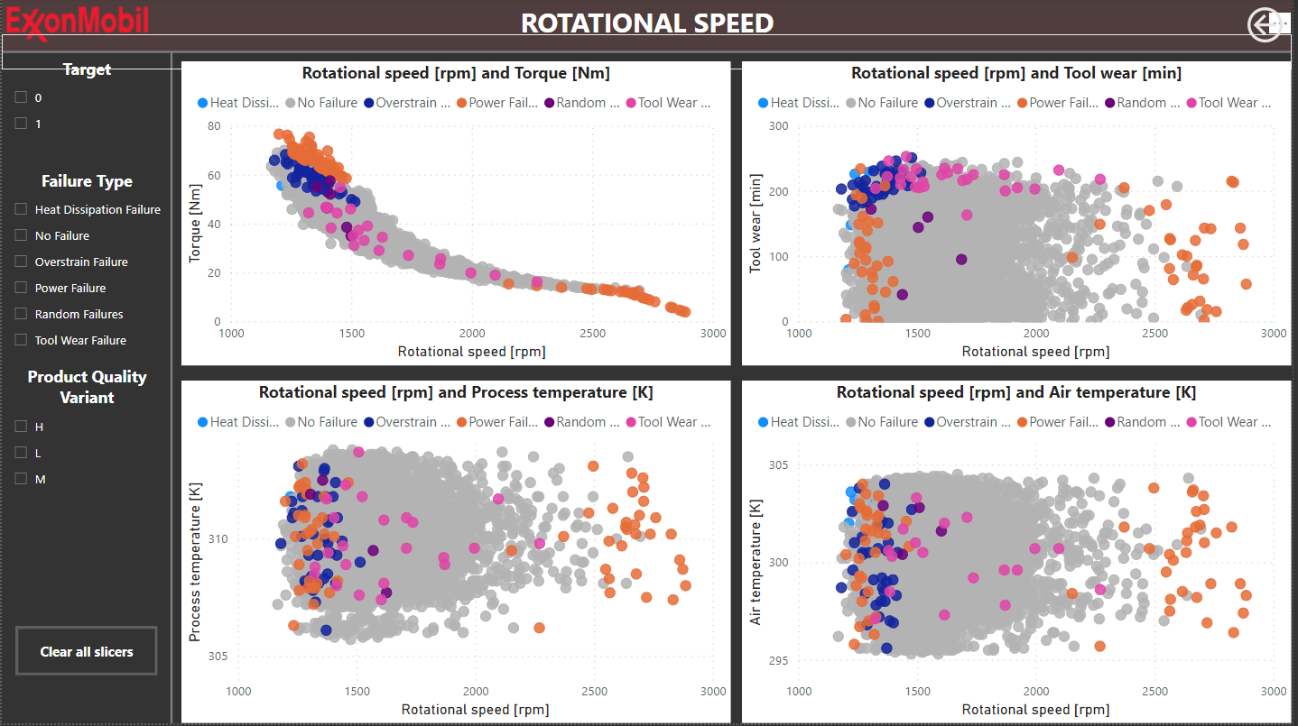

Process Temperature Variable:
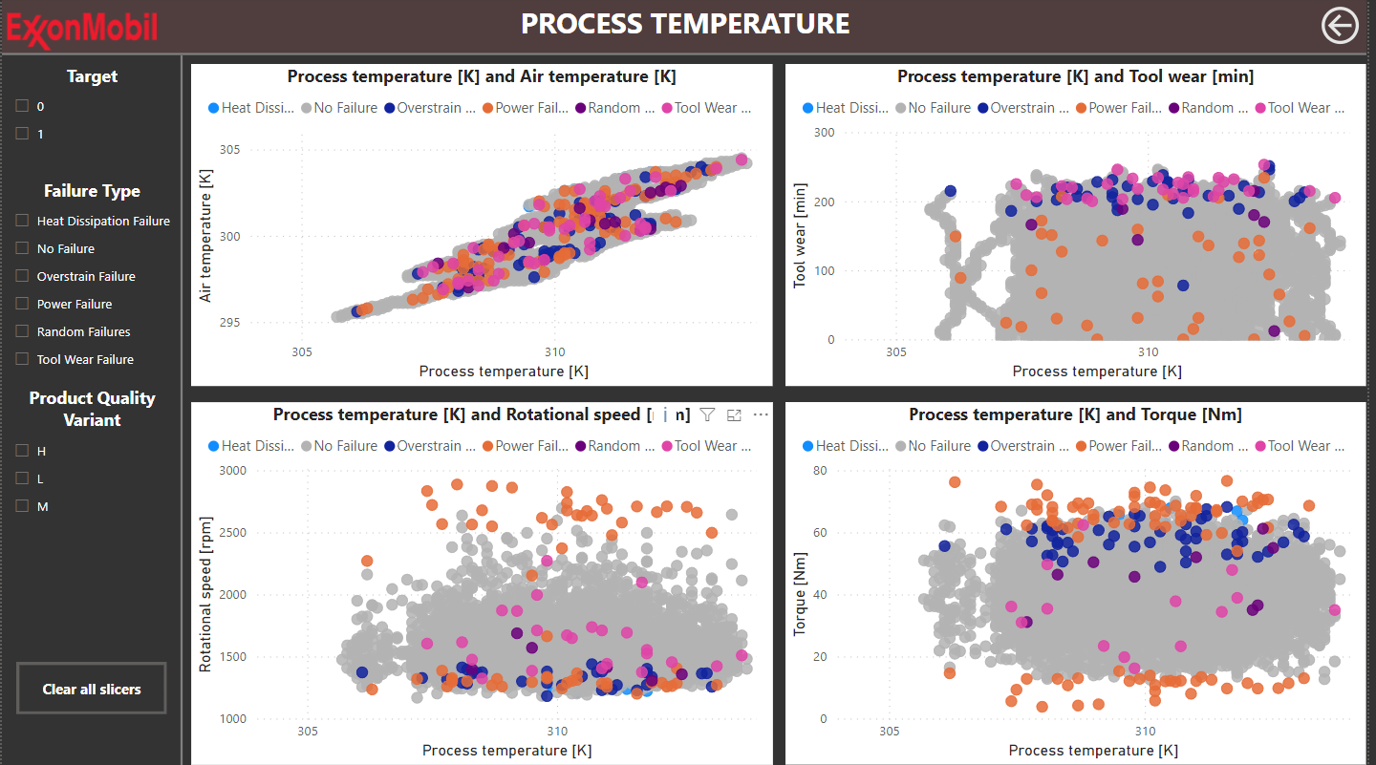
Tool Wear Variable:
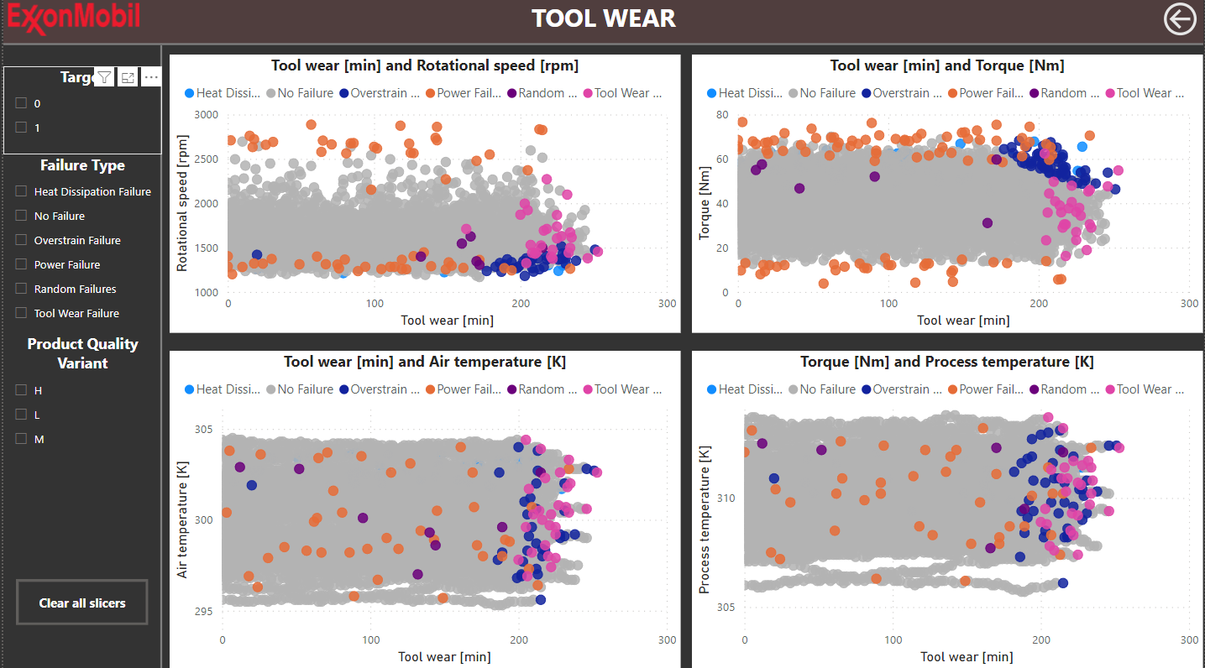

Torque Variable:
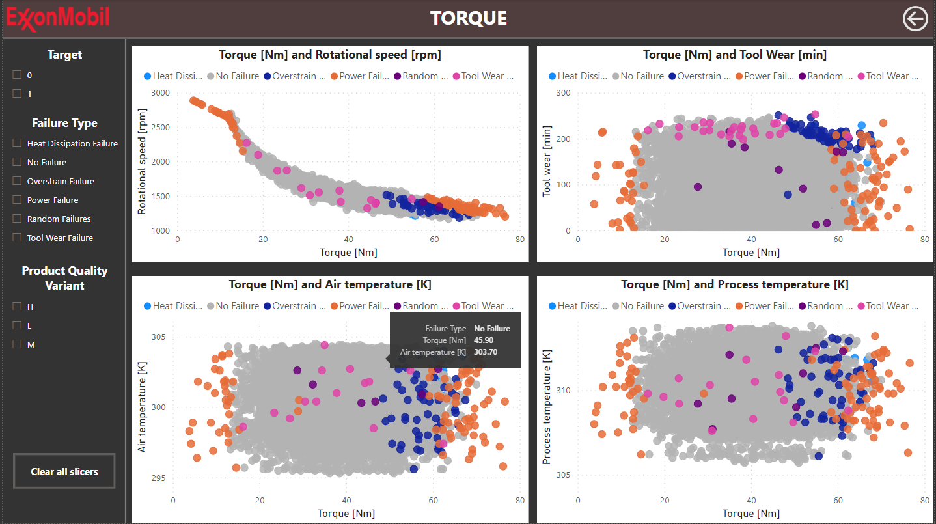

Appendix C: References
Achouch, M., Dimitrova, M., Ziane, K., Sattarpanah Karganroudi, S., Dhouib, R., Ibrahim, H., & Adda, M. (2022). On Predictive Maintenance in Industry 4.0: Overview, Models, and Challenges. Applied Sciences, 12(16), 8081. https://doi.org/10.3390/app12168081

AI, Data & Analytics Network. (2023, August 29). ExxonMobil’s Well-Oiled Enterprise Data and Analytics approach. AI, Data & Analytics Network. https://www.aidataanalytics.network/business-analytics/articles/exxonmobils-well-oiled-enterprise-data-and-analytics-approach

Associated Press, & Doha Madani. (2019, August 1). 66 people sent for medical attention after ExxonMobil refinery explosion in Texas. NBC News. https://www.nbcnews.com/news/us-news/66-people-receiving-medical-attention-after-exxonmobil-refinery-explosion-texas-n1037581

Begum, S. (2022, October 26). S’pore will reach its 200MWh energy storage target 3 years early with new giant storage system. The Straits Times. https://www.straitstimes.com/singapore/s-pore-will-reach-its-200mwh-energy-storage-target-3-years-early-with-new-giant-storage-system

BSIC. (2023, November 5). ExxonMobil to acquire Pioneer Natural Resources in $59.5bn deal – BSIC | Bocconi Students Investment Club. https://bsic.it/exxonmobil-to-acquire-pioneer-natural-resources-in-59-5bn-deal/

Chantal Da Silva. (2021, December 23). Several people injured after fire at Exxon oil refinery in Texas. NBC News. https://www.nbcnews.com/news/us-news/explosion-fire-baytown-texas-exxonmobil-oil-refinery-rcna9756

Chowdhury, T. S., Mohsin, F. T., Tonni, M. M., Mita, M. N. H., & Ehsan, M. M. (2023). A critical review on gas turbine cooling performance and failure analysis of turbine blades. International Journal of Thermofluids, 18, 100329. https://doi.org/10.1016/j.ijft.2023.100329

Cohen, I. G., Babic, B., Gerke, S., Xia, Q., Evgeniou, T., & Wertenbroch, K. (2023). How AI can learn from the law: putting humans in the loop only on appeal. Npj Digital Medicine, 6(1), 1–4. https://doi.org/10.1038/s41746-023-00906-8

Deloitte (2017). Predictive Maintenance Taking pro-active measures based on advanced data analytics to predict and avoid machine failure. [online] Available at: https://www2.deloitte.com/content/dam/Deloitte/de/Documents/deloitte-analytics/Deloitte_Predictive-Maintenance_PositionPaper.pdf.

DeNittis, N. (2023, February 15). Artificial intelligence at ExxonMobil – two applications at the largest Western oil company. Emerj Artificial Intelligence Research. https://emerj.com/ai-executive-guides/artificial-intelligence-at-exxonmobil/

Edb.gov.sg. (n.d.). https://www.edb.gov.sg/en/our-industries/energy-and-chemicals.html

Editor. (2021, June 14). INSPECTION FOR ENHANCED SAFETY & PERFORMANCE AT THE EXXONMOBIL CHEMICAL PLANT - FieldCore. FieldCore. https://www.fieldcore.com/inspection-for-enhanced-safety-performance-at-the-exxonmobil-chemical-plant/

Export.gov. (2019). https://www.export.gov/apex/article2?id=Singapore-Oil-and-Ga

Emre Sezgin. (2023). Artificial intelligence in healthcare: Complementing, not replacing, doctors and healthcare providers. DIGITAL HEALTH, 9. https://doi.org/10.1177/20552076231186520

ExxonMobil. (2022, January 7). Operations Integrity Management System (OIMS) process. ExxonMobil. https://corporate.exxonmobil.com/who-we-are/technology-and-collaborations/energy-technologies/risk-management-and-safety/operations-integrity-management-system
Exxonmobil. (n.d.). Risk management and safety. ExxonMobil. https://corporate.exxonmobil.com/who-we-are/technology-and-collaborations/energy-technologies/risk-management-and-safety
ExxonMobil’s Singapore Refinery Expansion - NS Energy. (2019b, September 3). NS Energy. https://www.nsenergybusiness.com/projects/exxonmobils-singapore-refinery-expansion/

ExxonMobil. (n.d.). Doing our part | Energy transition. ExxonMobil. Retrieved March 31, 2024, from https://corporate.exxonmobil.com/locations/singapore/doing-our-part-for-the-energy-transition#LoweremissionfuelsLEF

“ExxonMobil.” Wikipedia, 21 May 2022, en.wikipedia.org/wiki/ExxonMobil#:~:text=ExxonMobil%20is%20the%20largest%20non.

FORRESTER OPPORTUNITY SNAPSHOT: A CUSTOM STUDY COMMISSIONED BY IBM AUGUST 2019. (2019). Accelerate Recovery With New Technologies FORRESTER OPPORTUNITY SNAPSHOT: A CUSTOM STUDY COMMISSIONED BY IBM. https://www.ibm.com/downloads/cas/L57KW7ND

FieldCore. (2019, May 9). INSPECTION FOR ENHANCED SAFETY & PERFORMANCE AT THE EXXONMOBIL CHEMICAL PLANT. FieldCore. https://www.fieldcore.com/inspection-for-enhanced-safety-performance-at-the-exxonmobil-chemical -plant/

Field / Maintenance Engineer. (n.d.). Jobs.exxonmobil.com. https://jobs.exxonmobil.com/ExxonMobil/job/Raigad-Field-Maintenance-Engineer-MH/1100661900/

Graf, W. H., Vukovich , W. F., & Yeung, T. W. (2013, October). Refinery power failures: causes, costs and solutions: part 2. Www.digitalrefining.com. https://www.digitalrefining.com/article/1000846/refinery-power-failures-causes-costs-and-solutions-part-2

Gremban, K., Betts, D., Rathnavel, U., & Pettibone, G. (n.d.). IoT concepts and Azure IoT Hub. Learn.microsoft.com. https://learn.microsoft.com/en-us/azure/iot-hub/iot-concepts-and-iot-hub

Gulvin, L. (2023, May 31). Preventive maintenance vs. predictive maintenance. IBM Blog. https://www.ibm.com/blog/predictive-vs-preventive-maintenance/
Industrial Maintenance | Gear Inspection | MobilTM. (n.d.). https://www.mobil.com/en/sap/business/services/gear-inspection

Koons, E. (2022, August 25). Top oil and gas companies in Singapore. Energy Tracker Asia. https://energytracker.asia/top-oil-and-gas-companies-in-singapore/

Lavi Mendes, N. (n.d.). Overview of Azure Monitor Alerts - Azure Monitor. Learn.microsoft.com. https://learn.microsoft.com/en-us/azure/azure-monitor/alerts/alerts-overview

Liu, M., Chan, Y. Z., Ministry of Trade and Industry, & Economics Division. (2023). External demand reliance of sectors in Singapore’s economy. https://www.mti.gov.sg/Resources/feature-articles/2023/External-Demand-Reliance-of-Sectors-in-Singapore-Economy

Masaya Mori. (2020, July 11). An overview of human-In-the-loop in AI system for the better future. Medium. https://medium.com/@masaya.mori/an-overview-of-human-in-the-loop-in-ai-system-for-the-better-future-1fe757042fe4

Magazine, B. (2020, February 3). ExxonMobil’s refinery maintenance and turnarounds higher in 4Q19. BIC Magazine. https://www.bicmagazine.com/departments/operations/exxonmobil%E2%80%99s-refinery-maintenance-and-turnarounds/

Mehdi. (2023, June 5). Predictive vs Preventive Maintenance: Differences & Benefits. Ocp Maintenance Solutions. https://ocp-ms.com/predictive-maintenance-vs-preventive-maintenance-complete-guide/

McKendrick, J. (2022, February 28). Responsible Artificial Intelligence Is Still Out Of Reach For Many Organizations. Forbes. https://www.forbes.com/sites/joemckendrick/2022/02/28/responsible-artificial-intelligence-is-still-out-of-reach-for-many-organizations/?sh=2932a5c3231f
Mohammed, A., & Kora, R. (2023). A Comprehensive Review on Ensemble Deep Learning: Opportunities and Challenges. Journal of King Saud University - Computer and Information Sciences, 35(2). https://doi.org/10.1016/j.jksuci.2023.01.014

Murray, J. (2019, December 1). Nine oil and gas companies leading the use of predictive maintenance. NS Energy. https://www.nsenergybusiness.com/features/predictive-maintenance-oil-and-gas/

Nwankwo, C. D., Arewa, A. O., Theophilus, S. C., & Esenowo, V. N. (2021). Analysis of accidents caused by human factors in the oil and gas industry using the HFACS-OGI framework. International Journal of Occupational Safety and Ergonomics, 1–13. https://doi.org/10.1080/10803548.2021.1916238
Operations Integrity Management System: Chairman’s message. (n.d.). ExxonMobil. https://corporate.exxonmobil.com/who-we-are/technology-and-collaborations/energy-technologies/risk-management-and-safety/operations-integrity-management-system-chairman-message
Ogunfowora, O., & Najjaran, H. (2023). Reinforcement and deep reinforcement learning-based solutions for machine maintenance planning, scheduling policies, and optimization. Journal of Manufacturing Systems, 70, 244–263. https://doi.org/10.1016/j.jmsy.2023.07.014

Pharaon, Jean W (2022). An Agilized Total Productive Maintenance Framework to Reduce Unplanned Downtime [Doctoral dissertation, George Washington University]. ProQuest Dissertations & Theses Global. https://www.proquest.com/docview/2611646259

Prometheus Group (2022). Reactive Vs. Preventive Vs. Predictive Maintenance | Prometheus Group. [online] Available at: https://www.prometheusgroup.com/resources/posts/reactive-vs-preventive-vs-predictive-maintenance.

Rotor-In Major Inspection for Gas Turbines | GE Vernova. (n.d.). Gepower-v2. https://www.gevernova.com/gas-power/services/gas-turbines/upgrades/rotor-major-inspection

Reuters. (2019, February 23). Exxon, Microsoft strike cloud computing agreement for U.S. shale [Review of Exxon, Microsoft strike cloud computing agreement for U.S. shale]. https://www.reuters.com/article/idUSKCN1QB1P1/
Review on Explainable Artificial Intelligence. Cognitive Computation. https://doi.org/10.1007/s12559-023-10179-8
Schiff, T. (2016, February 22). Plant Engineering Maintenance Study | MobilTM. https://www.mobil.ca/en-ca/lubricants/industrial/lubricant-expertise/resources/plant-engineering-maintenance-study

Seba, E. (2017, July 14). Exxon Mobil fined for Louisiana refinery explosion that injured four [Review of Exxon Mobil fined for Louisiana refinery explosion that injured four]. https://www.reuters.com/article/idUSKBN19Y2AV/

Sontag, D. (2019, April 17). Zero Downtime: How to start out with Predictive Maintenance. Medium. https://medium.com/the-industry-4-0-blog/zero-downtime-how-to-start-out-with-predictive-maintena nce-3538bf0fec46

Statista. (2023b, August 25). ExxonMobil’s refining capacity by region 2011-2022. https://www.statista.com/statistics/281188/refining-capacity-of-exxon-mobil-by-region/
Tyrrell, P. (2023, September 15). Reactive Maintenance Challenges. FieldInsight. https://www.fieldinsight.com/blog/reactive-maintenance-challenges/#:~:text=In%20contrast%2C%20reactive%20maintenance%20may

Vernova, G. (n.d.). Rotor-In Major Inspection for Gas Turbines | GE Gas Power. Gepower-V2. Retrieved March 1, 2024, from https://www.gevernova.com/gas-power/services/gas-turbines/upgrades/rotor-major-inspection

Vernova, G. (n.d.). 9HA Gas Turbine | 9HA.01 and 9HA.02 | GE Vernova. Gepower-V2. https://www.gevernova.com/gas-power/products/gas-turbines/9ha
Seba, E. (2017, July 14). Exxon Mobil fined for Louisiana refinery explosion that injured four. https://www.reuters.com/article/idUSKBN19Y2AV/
Vikas Hassija, Vinay Chamola, Mahapatra, A., Singal, A., Goel, D., Huang, K., Scardapane, S., Spinelli, I., Mahmud, M., & Hussain, A. (2023). Interpreting Black-Box Models: A
Wahid, A., Breslin, J. G., & Intizar, M. A. (2022). Prediction of Machine Failure in Industry 4.0: A Hybrid CNN-LSTM Framework. Applied Sciences, 12(9), 4221. https://doi.org/10.3390/app12094221

What is reactive maintenance? | IBM. (n.d.). Www.ibm.com. https://www.ibm.com/topics/reactive-maintenance

What we do. ExxonMobil. (n.d.). https://corporate.exxonmobil.com/what-we-do

Zonta, T., da Costa, C. A., da Rosa Righi, R., de Lima, M. J., da Trindade, E. S., & Li, G. P. (2020). Predictive maintenance in the Industry 4.0: A systematic literature review. Computers & Industrial Engineering, 150, 106889.

Appendix D: Declaration of Academic Integrity


Appendix C: Air Temperature VariableAppendix C: Air Temperature Variable

